MEHRAN UNIVERSITY

OF ENGINEERING & TECHNOLOGY

JAMSHORO, PAKISTAN

Subject: Software Construction and Development

(Lab 7 - Tasks Solution)

|  |  |
| --- | --- |
| **Roll No:** | **22SW028** |
| **Section:** | **I** |
| **Name** | **Arbab Hussain** |

**LAB 08 TASKS (Installation of Visual Studio and Azure DevOps Server)**

**1. INSTALLING VISUAL STUDIO:**

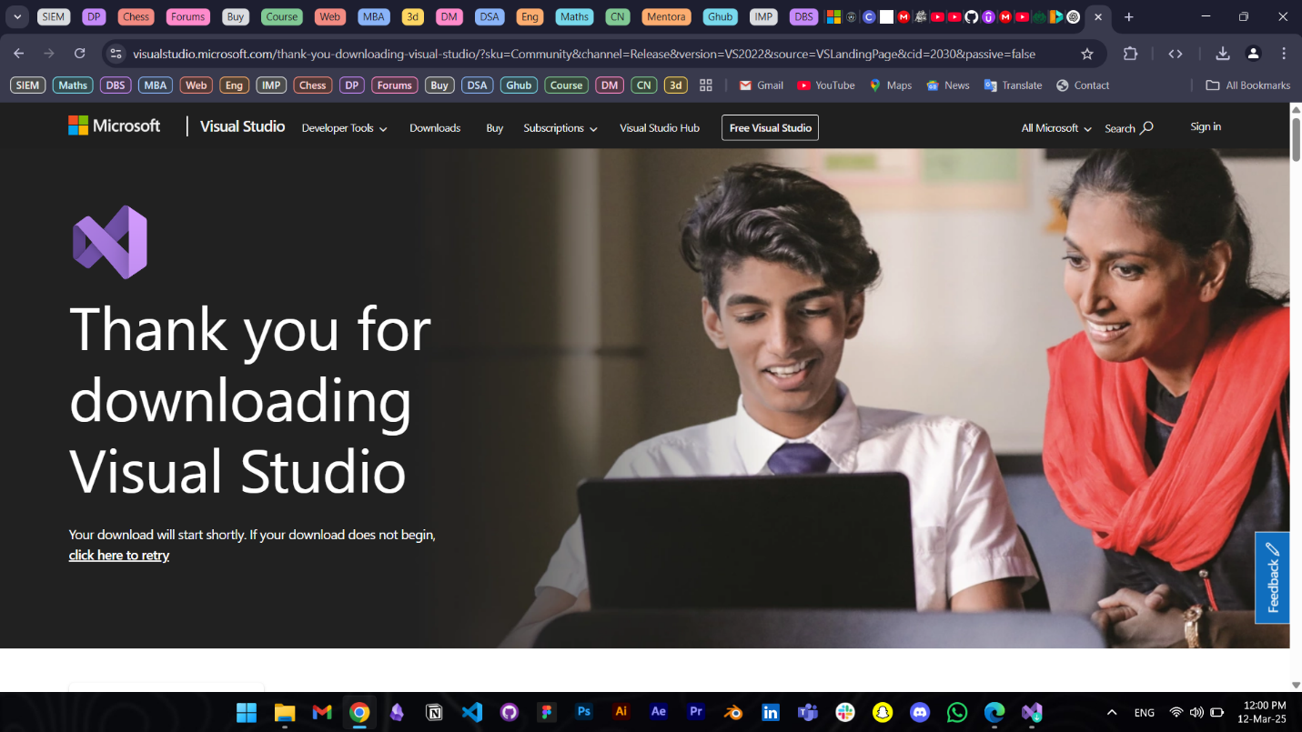

**VISUAL STUDIO’s HOME PAGE**

**2. INSTALLING AZURE DevOps Server:**

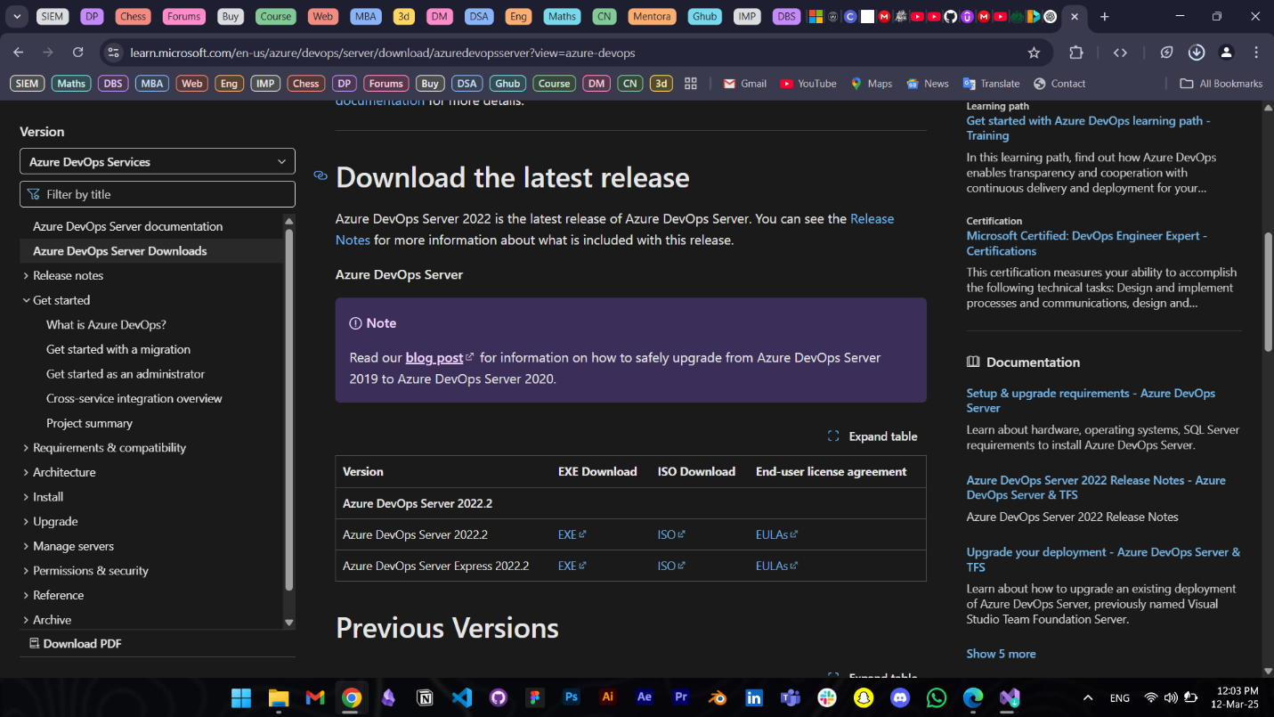

**ADMIN CONSOLE OF AZURE DEVOPS SERVER:**

Note: Azure DevOps Server supports creation of projects and testing in its web version, the desktop server is only for administrators to manage teams and pipelines.